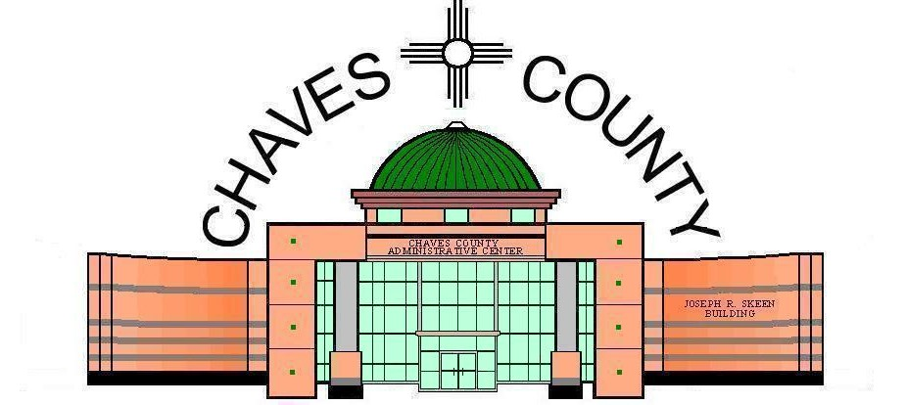
Public Services Office COMMISSIONERS
PO Box 1817 Dara Dana • District 1
Roswell, NM 88202-1817 T Calder Ezzell Jr • District 2
Phone (575)-624-6600 Jeff Bilberry • District 3
Fax (575)-624-6631 Richard C. Taylor • District 4
Michael Perry • District 5

Joseph R. Skeen Building County Manager
Bill Williams
August 27, 2024

PUBLISH: SEPTEMBER 1, 2024

NOTICE OF PUBLIC HEARING

CHAVES COUNTY BOARD OF COMMISSIONERS
SEPTEMBER 19, 2023, AT 9:00 A.M.
CHAVES COUNTY ADMINISTRATIVE CENTER
#1 ST. MARY’S PLACE, ROSWELL, NM
A public hearing to consider the following:
Revise Ordinance No. O-008 by Chaves County to revise Ordinance O-008, pertaining to the Chaves County Personnel Policy.
A copy of the Revised Ordinance O-008 is available at Chaves County Clerk’s Office for review.
Members of the public having protest and/or comments to offer may submit such protest and/or comments in writing or email at least one (1) day prior to this hearing to the Chaves County Administration, #1 St. Mary’s Place, Roswell, NM 88203, or in person at this public hearing.
If you are an individual with a disability who is in need of a reader, amplifier, qualified sign language interpreter, or any other form of auxiliary aid or service to attend or participate in the hearing or meeting, please contact the Chaves County Administration at 575 624-6600 at least one week prior to the meeting or as soon as possible.

